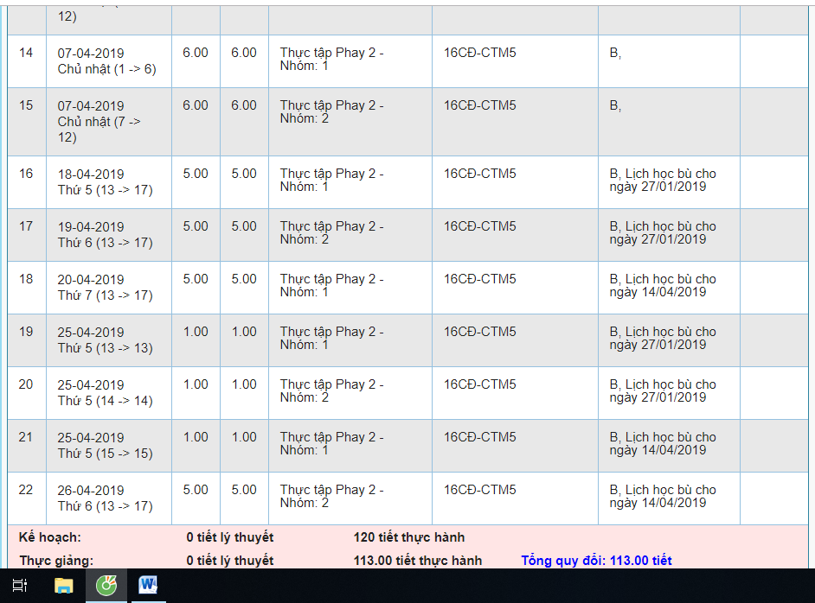
Lịch dạy bù 16CĐ CTM5

